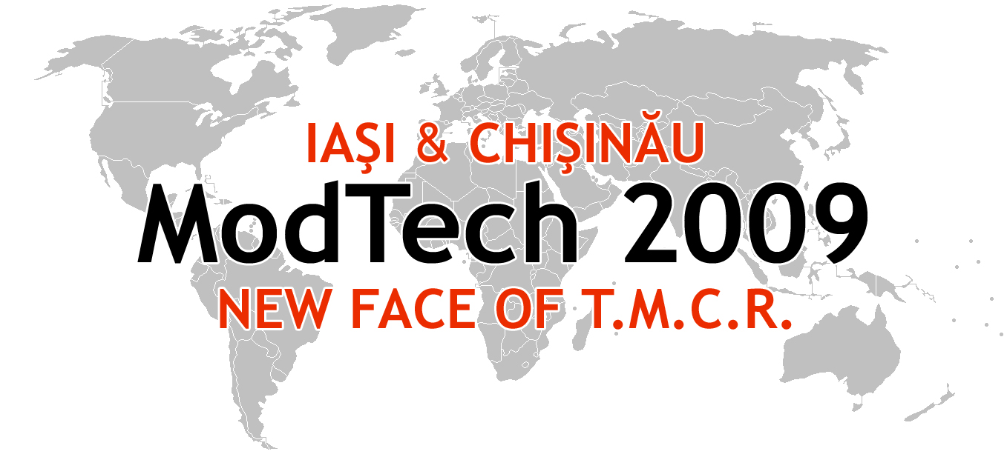

ModTech International Conference - New face of TMCR
Modern Technologies, Quality and Innovation - New face of TMCR
21-23rd May 2009
http://www.modtech.ro
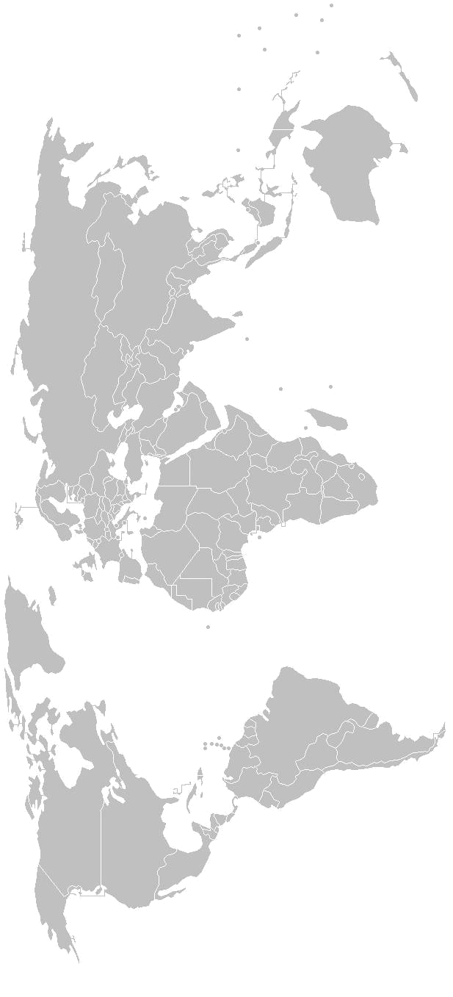
SECTION 8
Forming Technologies

A-3-09, Laboratory of Experimental Researching

Chair: Prof. Vasile Braha, Ph.D.
Co-Chair: lecturer Florin Negoescu, Ph.D.
Secretary: Carmen Motfolea, Ph.D. Student

Thursday  May 21 | Papers & Authors
15²⁰-15³⁵ | Springback reduction by using in the forming process design the neural networks or fuzzy logic methods  Gheorghe Brabie & Costache – Radu Mioara
15³⁵-15⁵⁰ | About structure of the main linkages  on cold forming machine-tools  Romeo Cioară
15⁵⁰-16⁰⁵ | Experimental researches regarding the working conditions for cold plastic deformation of metals  Leonte Petre, Octavian Pruteanu, Constantin Cărăuşu & Pricope Corneliu
16⁰⁵-16²⁰ | The effect of the deformation degree upon the form, the roughness and the micro-hardness of the surfaces processed through cold plastic deformation  Leonte Petre, Octavian Pruteanu, Constantin Cărăuşu & Şerban Cătălin
16²⁰-16³⁵ | Stresses and deformations in the contact zone of a longitudinal section between cylinders of cold rolling  Aurel-Dan Maimon, Liviu Stoicescu
16³⁵-16⁵⁰ | Comparative aspects concerning different superficial cold plastic deformation processes  Iolanda Poschin, Gheorghe Nagit, Mihai Boca, Sorin Popa
16⁵⁰-17⁰⁵ | Researches regarding the influence of the piece speed rotation on the quality parameters of processed surfaces through cold plastic deformation  Constantin Cărăuşu, Octavian Pruteanu, Ionel Sarbu, Radu Coman & Valerică Huşanu
17⁰⁵-17²⁰ | Researches regarding the influence of the force on the quality parameters of processed surfaces through cold plastic deformation  Octavian Pruteanu, Constantin Cărăuşu, Ionel Sarbu, Traian Grămescu, Mariana Pruteanu & Corneliu Pricope
17²⁰-17³⁵ | Device for superficial plastic deformation by mechanical shocks  Raluca Tanasa & Traian Gramescu
17³⁵-17⁵⁰ | Contributions regarding the realiztion of a device for rotorolling long externel cylindrical  Ovidiu Sava, Octavian Lupescu, Ionut Popa & Ramona Popa
17⁵⁰-18⁰⁵ | Considerations regarding on the use of slip lines method for determining efforts at blanking metal materials with high thickness  Carmen Motfolea, Vasile Braha

